**Motion Equation Practice 2**

1. Fill in the equation symbol and **Metric** **system** units for the following measurements.



|  |  |  |  |
| --- | --- | --- | --- |
| **Displacement** | **Velocity** | **Acceleration** | **Time** |
|  |  |  |  |

2. A flying saucer changes its velocity from 20 m/s to 60 m/s in 2 s.

a) What is its acceleration?



b) How far did it move?

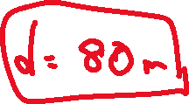

3. A baseball moves at a constant velocity of 40 m/s to home plate, which is 18.3 m away. How long does it take to reach the plate?

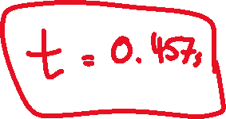

4. A car traveling at 22.4 m/s skids to a complete stop in 2.55 s. How far does the car go while braking?

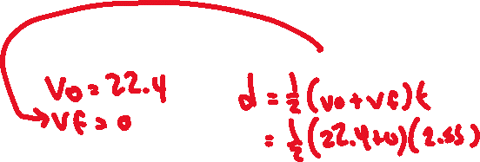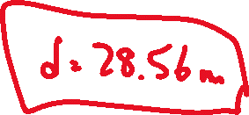

5. A bike is moving at 22 m/s, the rider hits the brakes, the bike slows down at -3 m/s2. How fast is the bike moving after 5 seconds?

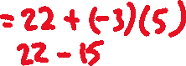

6. A cat starts running at 4 m/s, then speeds up at 3 m/s2, over 4 seconds. How far did he go?

